Lesson Plan
“Putting Tractor Safety in Motion”
Tractor Stability and ROPs

Instructor:
Course:
Unit:
Lesson Title:
Estimated Time:
Objective(s) of Lesson: What you want your students to KNOW and/or be able to DO
Objectives of Seminar:
- Properly inspect tractors for safety equipment
- Install or Maintain safety equipment using recommended industry standards on tractors
- Recognize and avoid hazardous situations involving tractors
- Explain center of gravity, centripetal force and angular momentum
- Discuss reaction time
- Research ROPs retrofit options for older tractors
- Identify safety recommendations in matching tractor size and tasks with the age and ability of the tractor operator.
- Perform a SAE risk assessment for tractor operations

Materials, Supplies, Equipment, References, and Other Resources:
- https://extension.psu.edu/navigating-the-say-national-clearinghouse
- https://extension.psu.edu/national-safe-tractor-and-machinery-operation-program
- https://extension.psu.edu/national-safe-tractor-and-machinery-operation-program-nstmop-instructor-training

Situation: (WHO are you teaching)
Agricultural Education students interested in updating SAE safety and agricultural mechanics safety. Motivation includes incorporating academic content (physics and math) with hands-on activities.

Interest Approach (Motivation):
Interest Approach

Farm tractors accounted for the deaths of 1,533 people between 2003 and 2011 and were of fatal occupational injuries in agriculture, forestry, and fishing. Today, tractor incidents remain the leading source of death and injury on farms. In 2011, only 59 percent of tractors had rollover protective structures (ROPs).

Before we begin today, we’d like you to think about some answers to the following question.

How do we decide what to focus your attention on?

Next, we have a short video for you.

Show video and facilitate discussion questions for a total of five minutes.
http://natgeotv.com.au/videos/brain-games/jason-silva-on-focus-6DB34C36.aspx

Interest Approach Questions for Discussion:
How stretched are you with processing all your SAE needs?
How do we decide what is useful information to get a job done?
When does a person run on autopilot?
Can you do this your eyes close?
What do we really see?

Communicate Objectives, Define Problem or Decision to be Made, or Identify Questions to Investigate:
Today we will more about opportunities for injury prevention and control by proper planning of SAE specific to tractor operations.

For our purposes, injuries are a result of an uncontrolled interaction between a host, an agent, and the environment. This seminar will be focused on safe tractor operations and assessing risks. The goal will be to accomplish as synergy in safety utilizing academic content standards and hands-on activities.

Instructor Directions / Materials  HOW you will teach | Content Outline, Instructional Procedures, and/or Key Questions  WHAT you will teach
NSTOMP Task Sheet 1 – Sections 1.2; 1.2.1; 1.2.2 | - Introduction with an overview of the agenda and purpose of research. Outline the rotations then ask for questions on logistics and rotation. Then have students take pretest.  - Laboratory and skill exercises need supervision.  - Show the website http://www.youthrules.gov/know-the-limits/agriculture/index.htm discuss what is allowable.  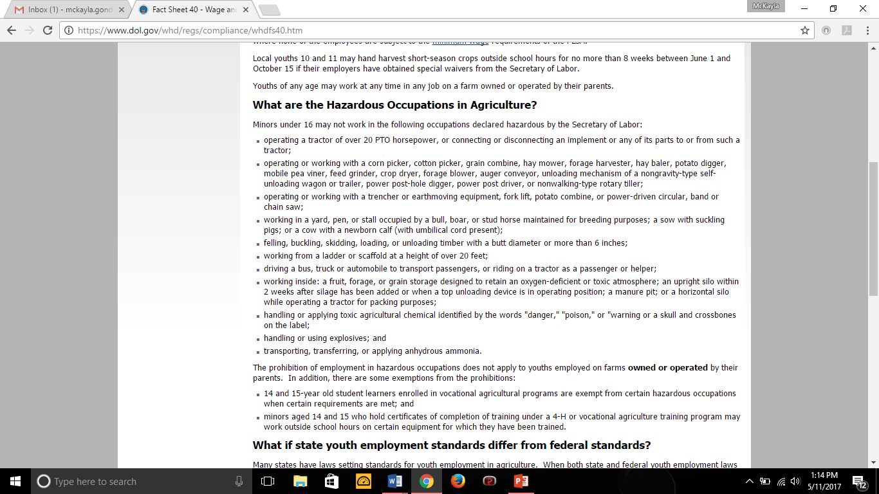
Walk-Around Job sheet using SAE Risk Assessment and NSTOMP Checklist  https://www.aem.org/safety-and-technical/safety/pictorial-database/ | *Small Group Break Out Session*  Rotation 1  Accomplishing Objective 1, 3, & 8:  - Properly inspect tractors for safety equipment  - Recognize and avoid hazardous situations involving tractors  - Perform a SAE risk assessment for tractor operation  Show video on hazards of tractors. https://youtu.be/mG0wA_hTDGk  https://www.youtube.com/playlist?list=PL66E3F5E433A5D988  Follow-up the videos up with hands-on activity.  Hands-on Activity  Option 1: Have a tractor on site for walk-around and inspect using SAE sheets and checklist from NSTMOP.  Option 2: Take students on a field trip to dealer and inspect using SAE sheets and checklist from NSTMOP.  Option 3: is to use digital pictures on PowerPoint to have teachers inspect using SAE sheets and checklist from NSTMOP.  In this rotation, you will be inspecting tractors for safety equipment, recognizing and avoiding hazardous situations, and performing an SAE Risk assessment.  The top XX items to inspect on every tractor are….  NSTOMP Task Sheet 4 – 4.2 & 4.6
Tilt Table Job Sheet | *Small Group Break Out Session*  Accomplishing Objective 4 & 5:  - Explain center of gravity, centripetal force and angular momentum  - Discuss reaction time  Show videos from YouTube  https://phet.colorado.edu/en/simulation/forces-and-motion-basics  https://youtu.be/9s1IRJbL2Co Centripetal force  https://youtu.be/zHpAifN_2Sw Centripetal Force II  Complete hands-on activity  Hands-On Activity  - Tilt Table Demonstration (center of gravity)  Students can then build demonstration units as part of hands-on skill development and demonstrate to the class their safety instruction function. Teachers and students could then use the kits to provide community outreach.  Hands-on Activity  Reaction time demonstration
Large Group
Accomplishing Objective 6:

- Research ROPs retrofit options for older tractors

Large group The Kentucky ROPS Guide,
http://warehouse.ca.uky.edu/rops/ropshome.asp
National ROPs Rebate Program,
program/

NSTOMP Task Sheet 2 – sections 2.1-2.4 | Large Group  Accomplishing Objective 7:  - Identify safety recommendations in matching tractor size and tasks with the age and ability of the tractor operator.  http://www.youthrules.gov/index.htm  https://www.cultivatesafety.org/child-development/  End session with a  review of youthrules.gov so that SAE multiple types can be  addressed.
Application: | Throughout the lesson
Closure/Summary: | Closing summary
Evaluation: | Post-test

